PART -A:

1 –

1. /proc
2. /boot
3. /home
4. /var/log
5. /root
6. /etc
7. /mnt
8. /dev
9. /usr/sbin
10. /etc/skel
11. /usr/lib
12. /lib
13. /usr/share/man
14. /var/mail

PART -B:

2 – ls -l vs ls -la

A: ls -l doesn’t show hidden files while ls -ls does.

8 –

1. tree ccgc

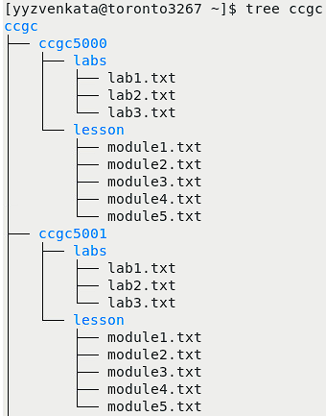

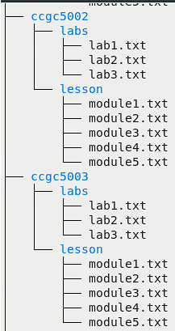

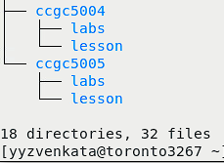

1. tree backup

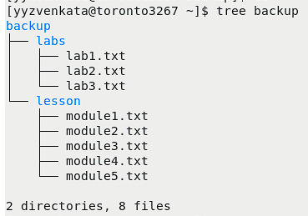

1. ls -lR ccgc

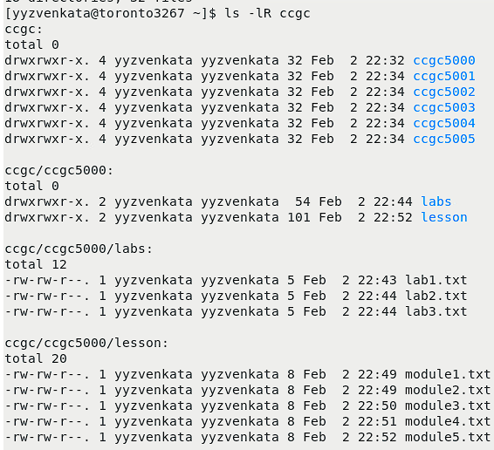

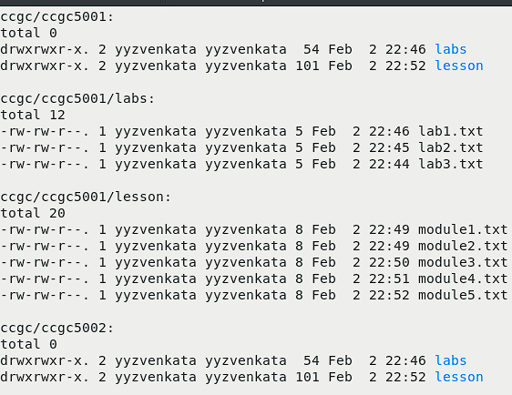

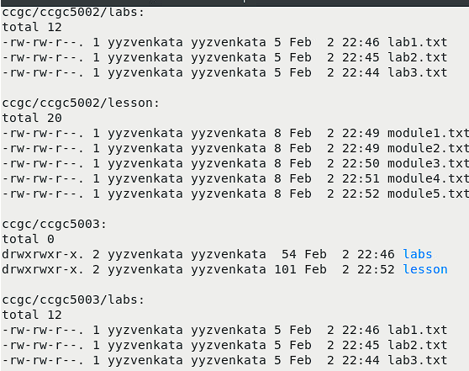

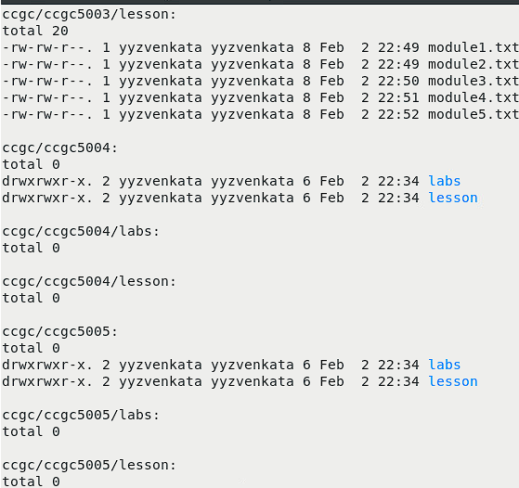

1. ls -lR backup

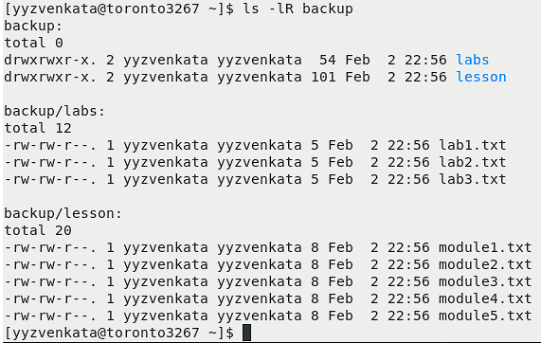

PART-C:

10.

a) tree cloud

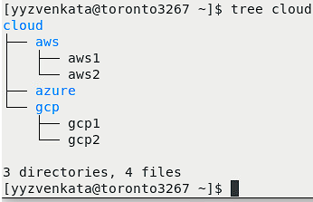

b) ls -lR cloud

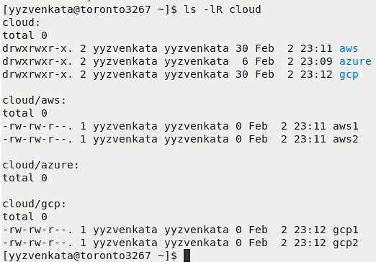

11. rmdir did not delete /cloud/aws as the aws folder is not empty. Instead using right command deletes aws folder i.e: rm -r cloud/aws

12. rmdir cloud/azure works because azure directory is empty.

13.

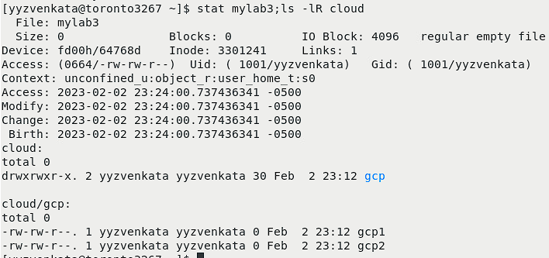

14.

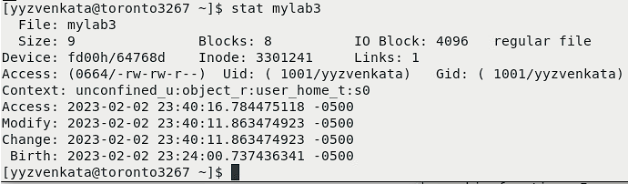

15.

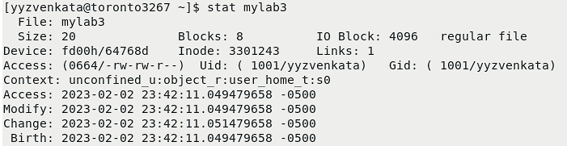

16.

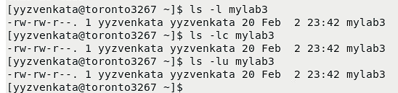

PART - D.

a)

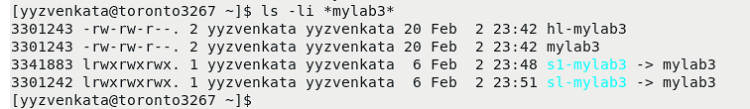

b)

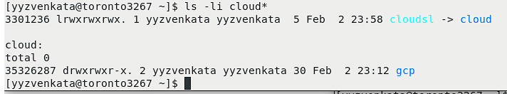

PART-E.

